**Models and Views:**

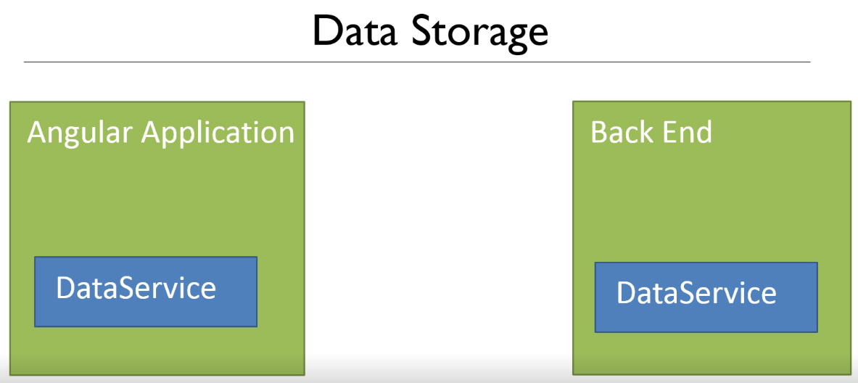

Final Goal:

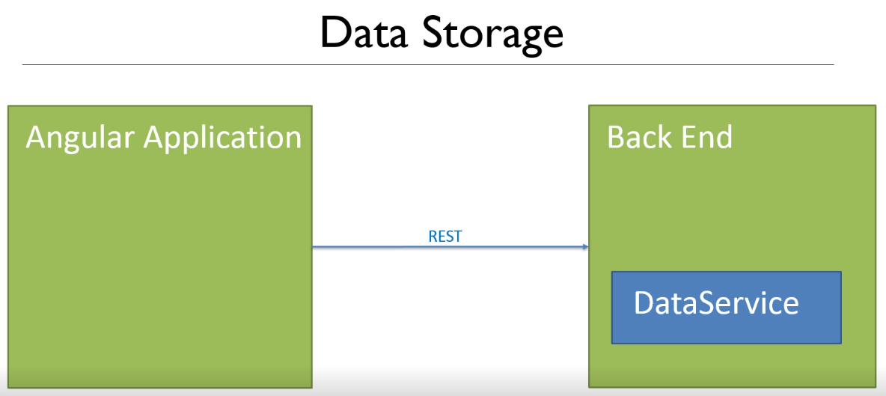

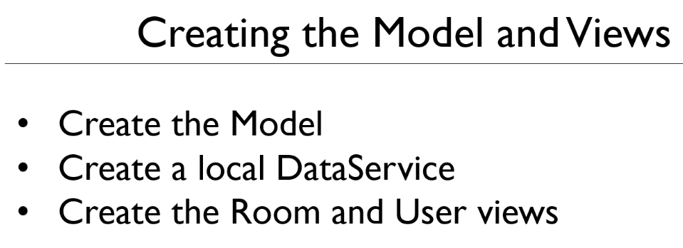

Create the Models

Room.ts class file in the model folder



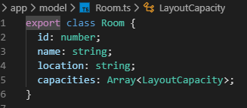

Refactored into a separate class

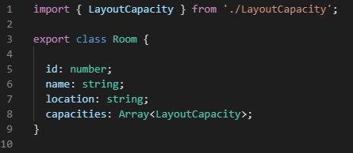

LayoutCapacity.ts class

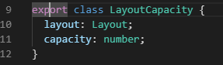

Refactored into a separated class

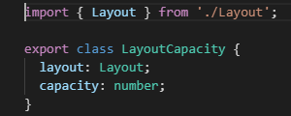

Layout.ts enum

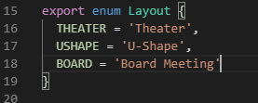

Create the data service

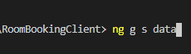

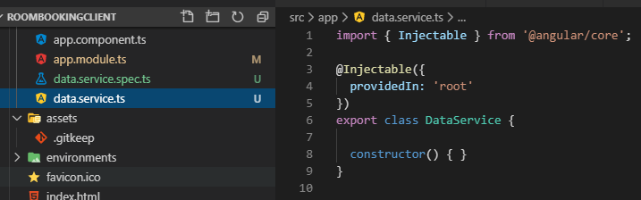

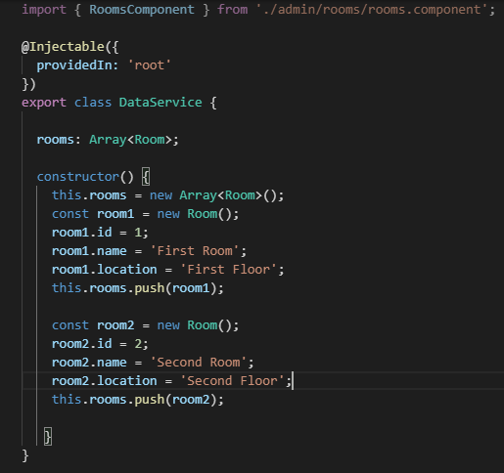

Modify the LayoutCapacity

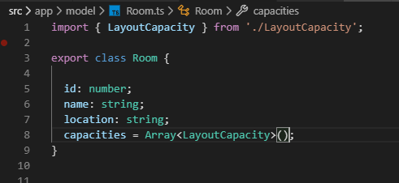

Add capacity

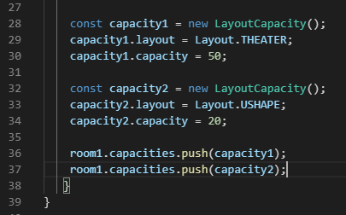

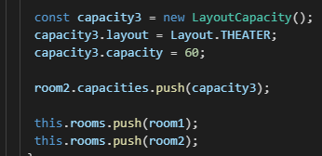

Now, populate the Rooms.component.ts for testing

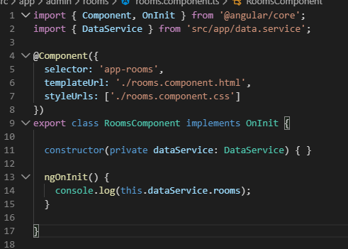

Click on Admin >> Rooms

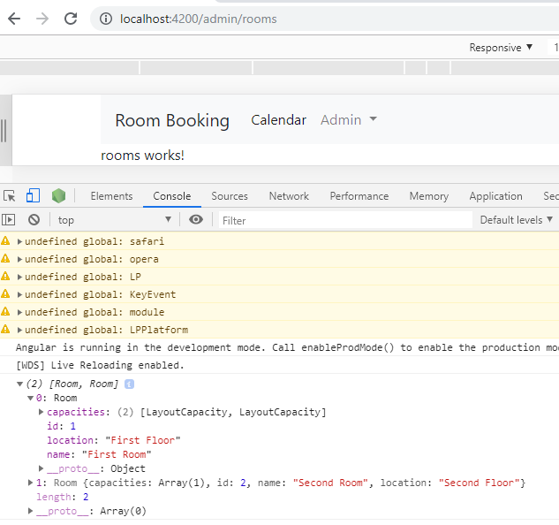

**Binding Data to View and Looping with NgFor**

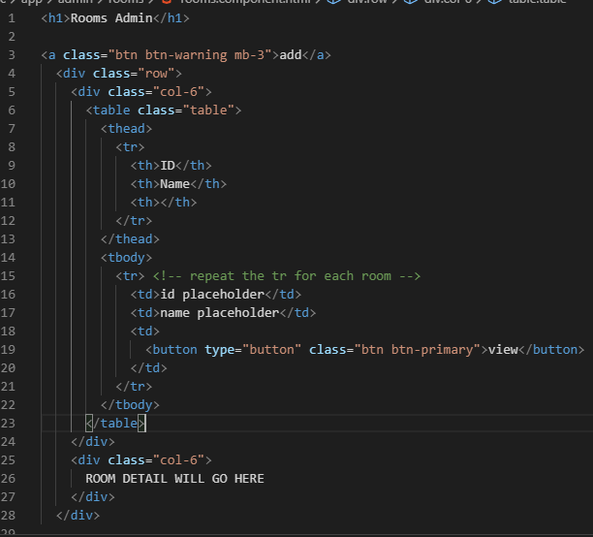

In the rooms.component.ts create a rooms array and populate

On load or on OnInt()

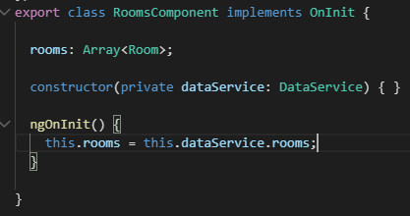

The * means a structural Directive that will not change the DOM.

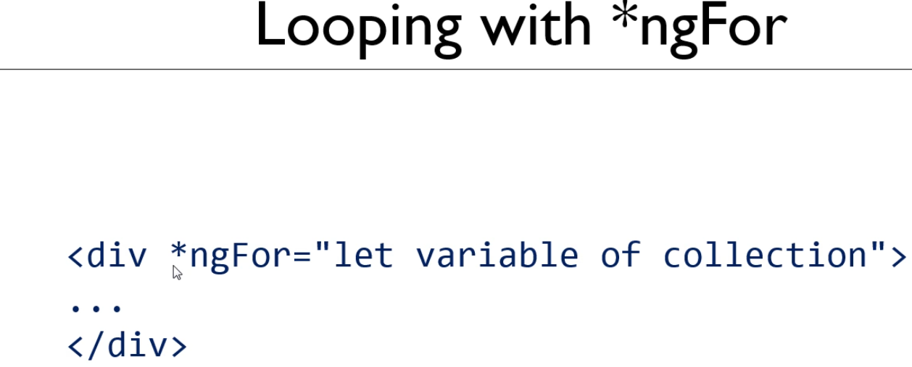

In the room.component.html file

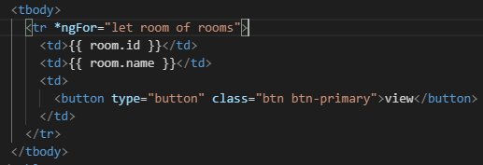

Test it in browser:

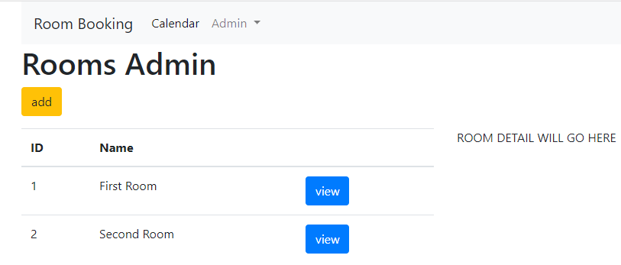

**Create a subcomponent:**

Click on the view, we get the details

In spring-boot it would look like this

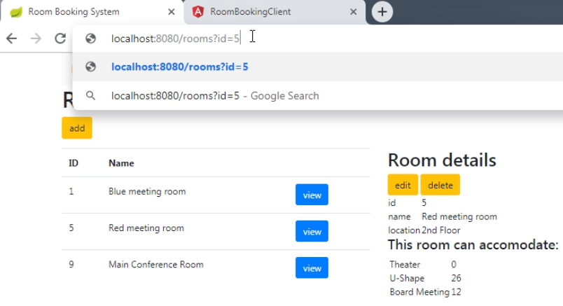

Create a new component for Details and change the url



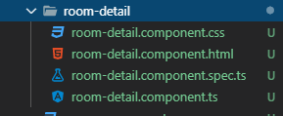

Copy the html from the spring app into the room-detail.component.html file

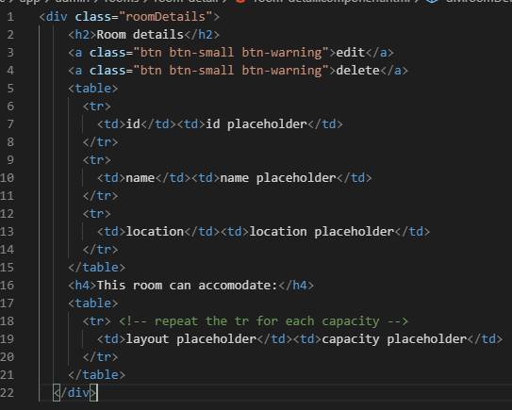

In the class file room-detail.ts file

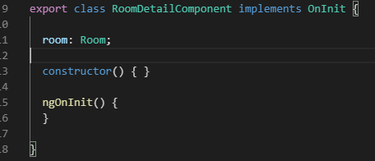

Back in the html fill in the room data:

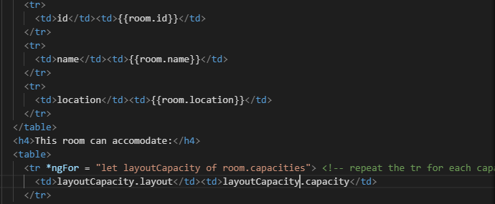

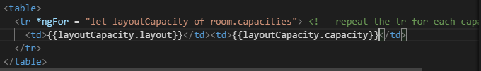

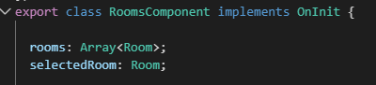

Now use the selectedRoom for the room-details

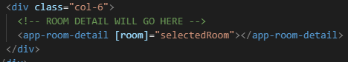

Let us temporary click event for testing We need a setRoom method

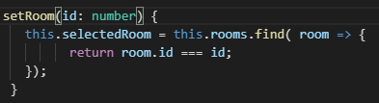

Simplify method by removing the {} and word return

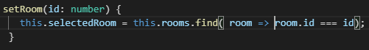

Add the click event to the button



Test the view button click

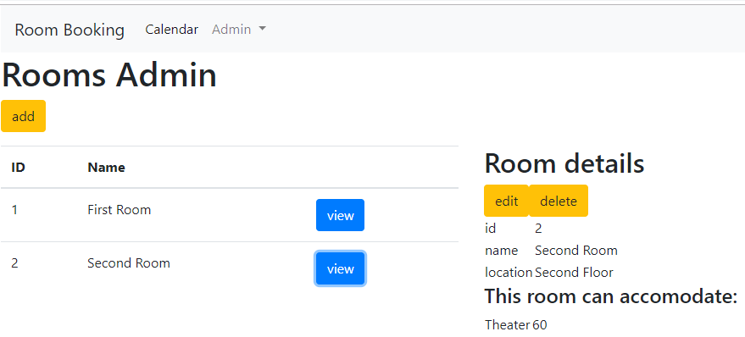

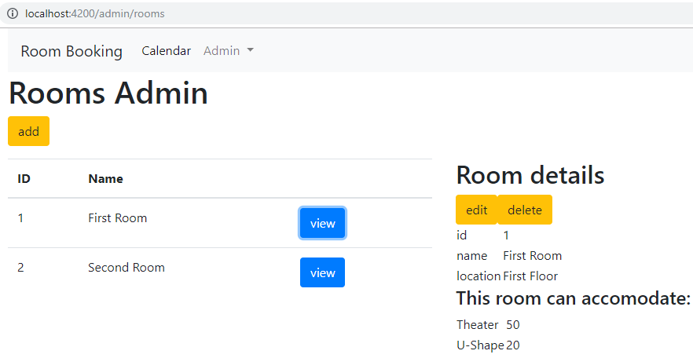

Now, fix the URL so that it changes with the view clicked

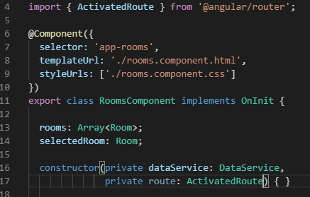

Added the ActivatedRoute to allow inspection of a passed parameter

We can look at the url in query params

Ignore the id error – its not really and error

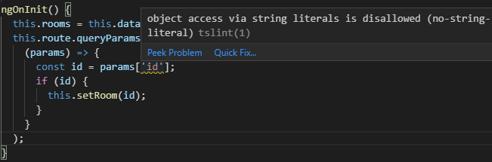

There is a string id versus a number id error

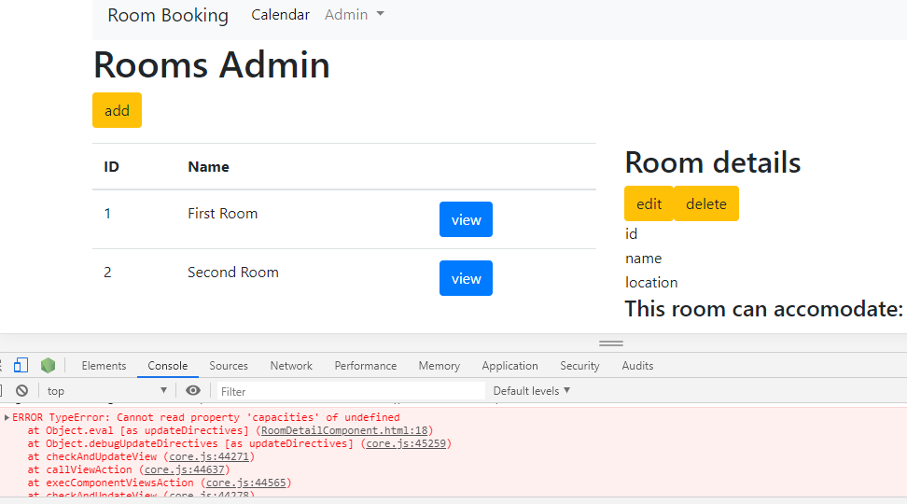

The way around this is to coerce the string id to a number when it is passed

The + plus sign does the trick



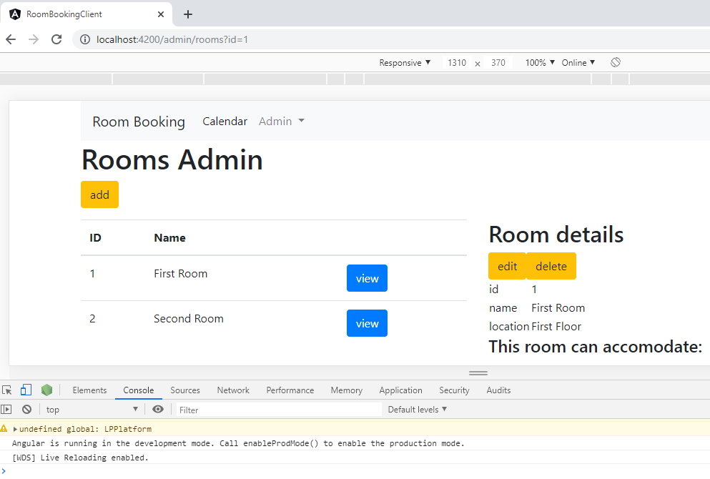Error is removed

Now, do navigation by adding a router

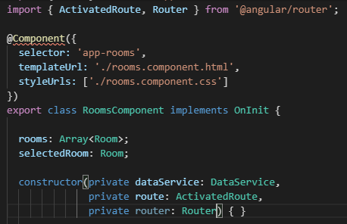

Swap out the call with its definition for id, so the click can perform a url navigation instead.

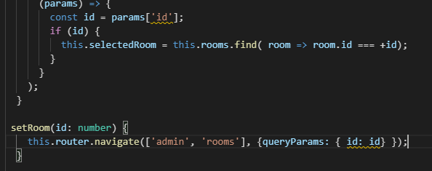

And the number url changes without error

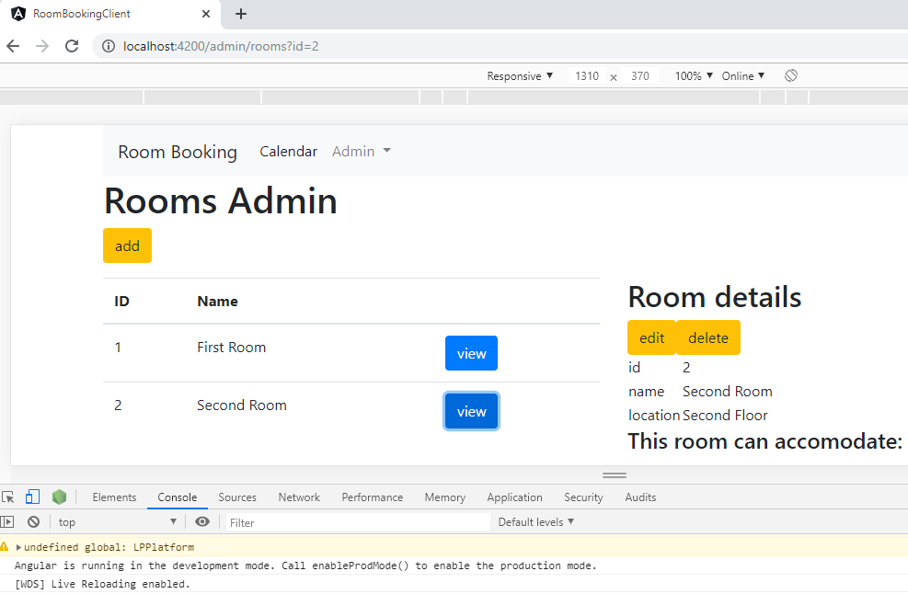

There is a shortcut when the key and value match you do not need the value

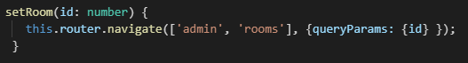

Let us hide the Room details if we have not clicked view



Exercise: Do the USERS object

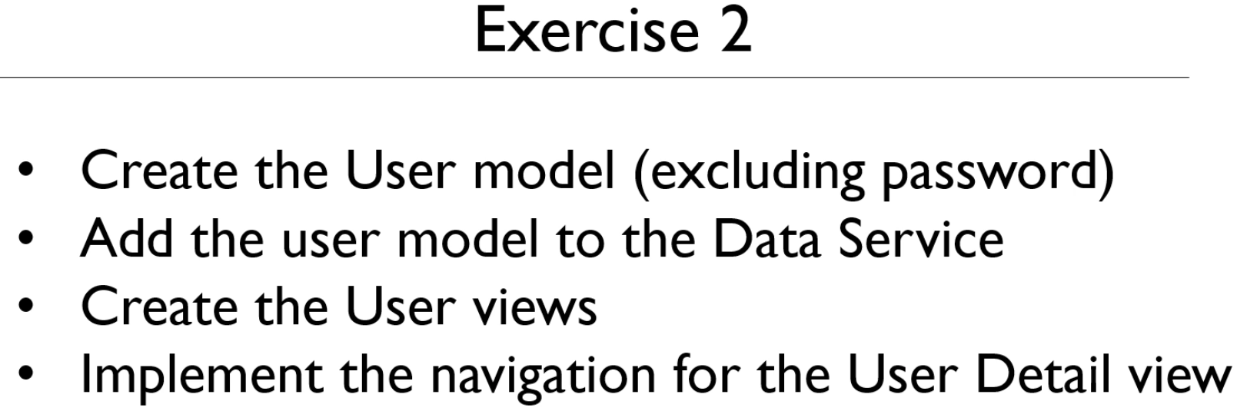

Create the model class User.ts file

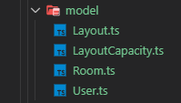

In the User.ts file we need 2 properties id and name

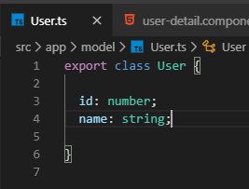

Go to the dataservice to create an array of users

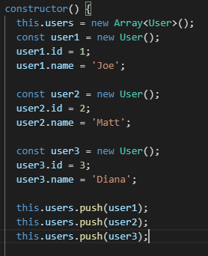

Generate the UserDetail Component

  
Dependency Inject the DataService

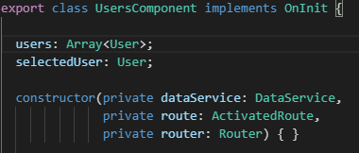

Implement the user.component.html file

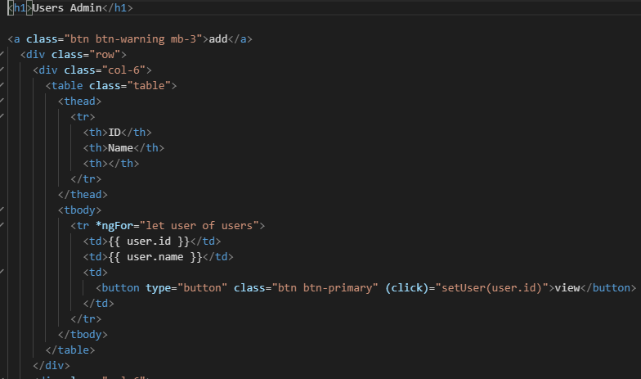

Create the setUser method comment out the user-details section until class is implemented

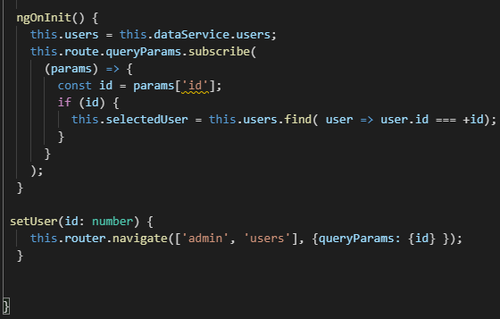

Put the html into the UserDetailComponent html

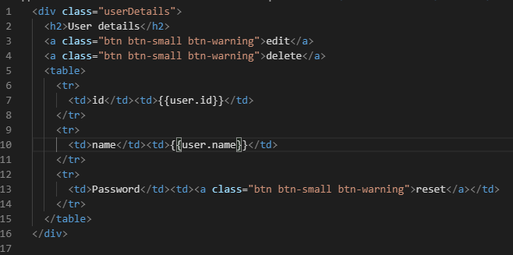

Add the @Input binding to the class file

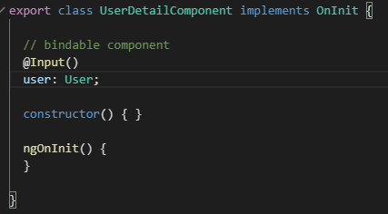

Implement the Details html code in the user.component.html file

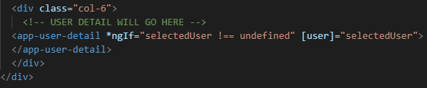

Compile with ng serve and test it

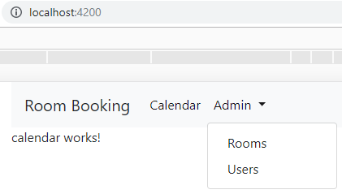

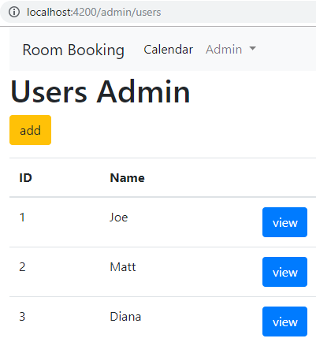

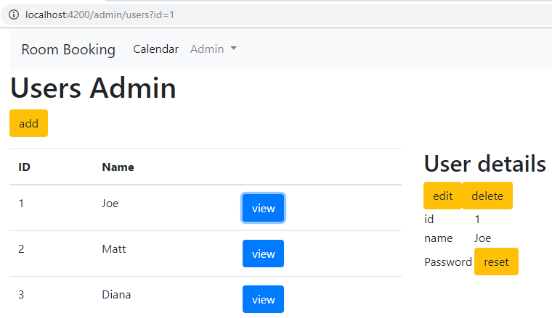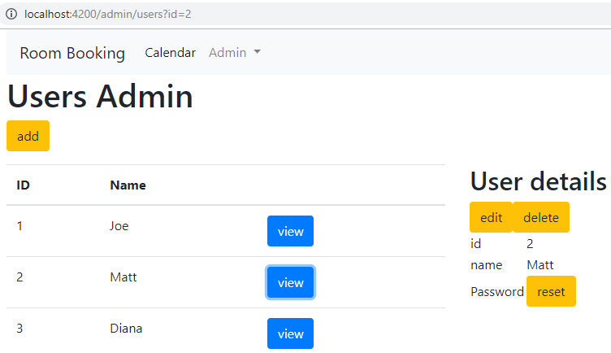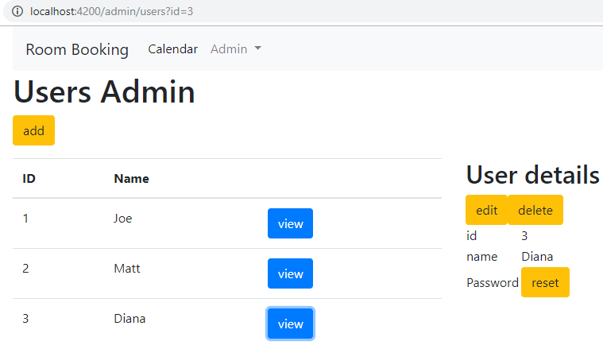

**Why use observables?**

**Fix the dataservice to use getter methods to obtain the data:**

**Setup Encapsulation: make properties private and add accessors**

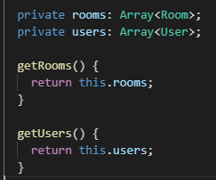

**Now, replace the rooms with getRooms() and users with getUsers() to implement the change**

**Erase users, type dot Ctrl+Space bar and the code suggestion appears**

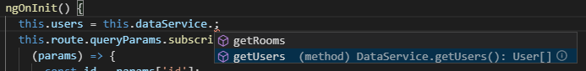

**Tab down to getUsers and press Enter.**



**Look for the this.dataService.rooms**



**Rest calls use the Observer design pattern**

**Mock up the subscription is returned instead of an array**

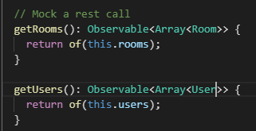

**Now implement the subscriptions**

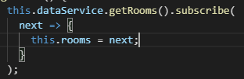

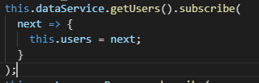

**Check for breakage**



Indicates a browser closed still running the server – solution kill the process at 4200

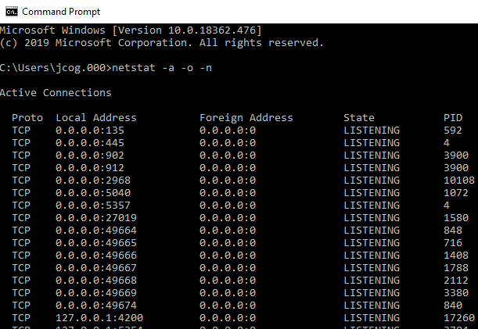

**The PID is 17260 for port 4200**

**So, to Kill the process type >taskkill /F /PID 17260 Press Enter**

